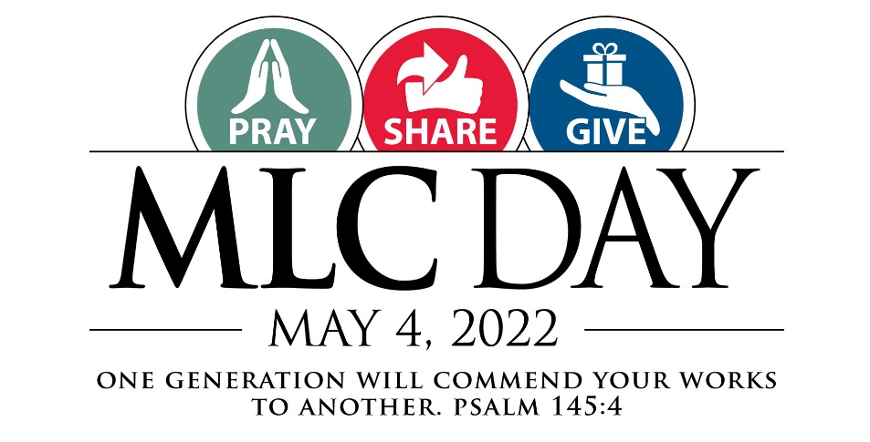
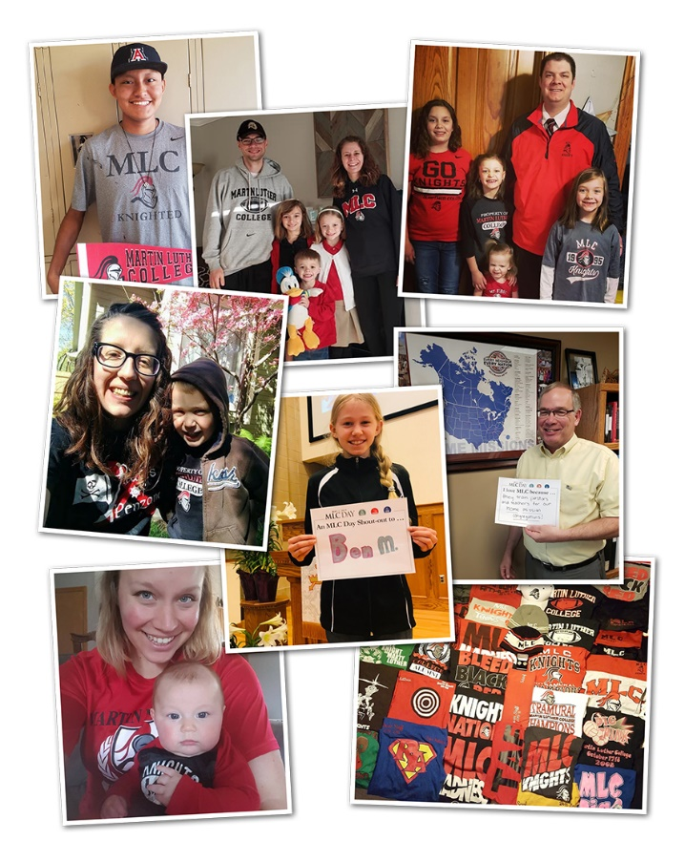
Celebrate MLC Day with us!
Dear Friends, join thousands of friends of Martin Luther College and WELS across the globe: pray for our work of service to the world, share messages of encouragement, and give to support that work.

What You Can Do:
Pray for our students, faculty, and staff, and for our mission of training the next generation of called workers to share the gospel with the world. Share your prayers on our MLC Day Kudoboards so we all can join together in those prayers.

Share a message of support or gratitude. Record a short video or snap a photo with your message (printable MLC Day signs are available at mlcday.com), and share it on our MLC Day Kudoboards, or post it on Facebook/Instagram using #MLCDAY22.

Talk about MLC in your conversations: on the phone, over coffee, at the golf course, or wherever! Think especially of opportunities to talk about MLC with young people in your congregation who might have an interest in training for the public ministry.

Give a gift to MLC. Your donation will directly assist MLC students by helping us fund the Congregational Partner Grant Program. A donor match is available to help us to reach our $100,000 goal.
Visit MLCDay.com to download printable signs and share your prayers, messages, photos, and videos.

